**Problem Statement 1:** Show step by step procedure to install android studio.

**Steps:**

1. Go to the official Android Studio website
2. Click Download Android Studio
3. Read and agree to the terms and conditions
4. Click Download Android Studio for Windows
5. Click Save File to start downloading
6. Open the downloaded file and run it
7. If prompted, click Yes to allow the installation to make changes to your computer
8. Follow the Setup Wizard in Android Studio
9. Install any recommended SDK packages

**Output:**

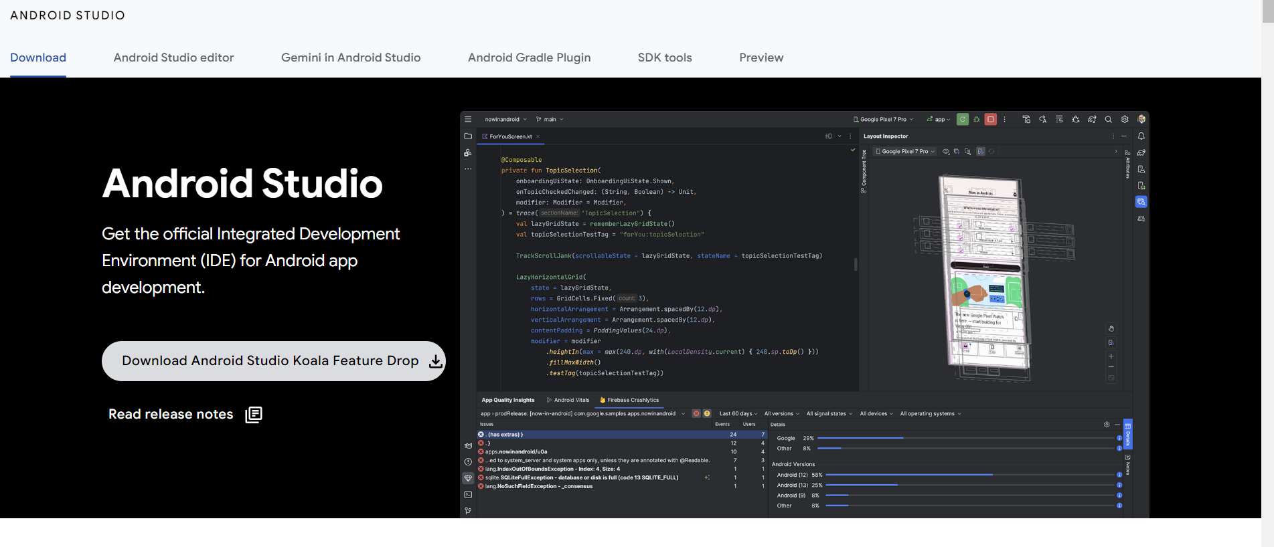

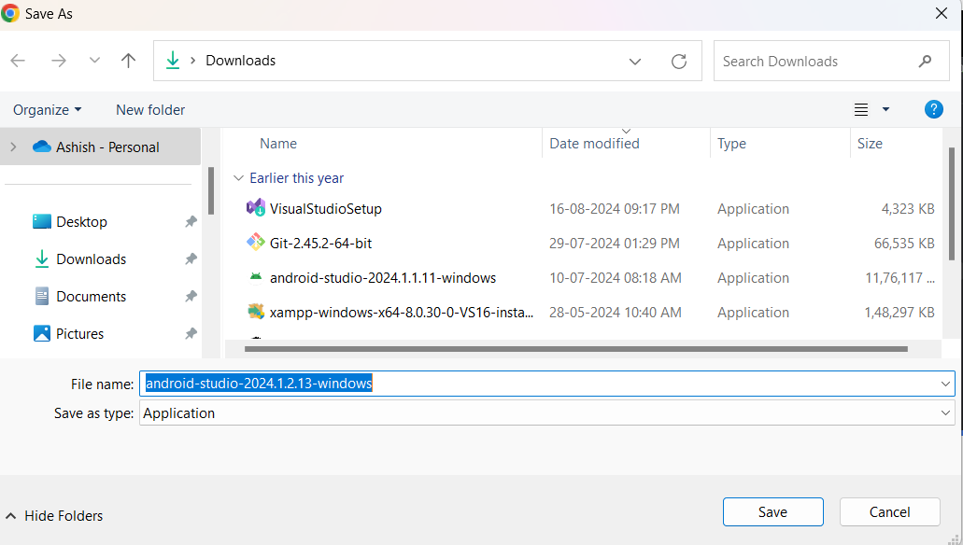

**Problem Statement 2:** Create a GitHub repository and push your project into the repository.

**Steps:**

**1. Create a New GitHub Repository**

1. Go to [GitHub](https://github.com/) and log in to your account.
2. Click on the **+** icon in the top-right corner and select **New repository**.
3. Give your repository a name and description (optional).
4. Leave it public or private depending on your choice.
5. Click **Create repository**.

You will now have an empty GitHub repository with a URL like:  
https://github.com/your-username/your-repo-name.git

**2. Open Your Project in Android Studio**

1. Open Android Studio.
2. Open your existing Android project.
3. Make sure that **Git** is initialized in the project. Android Studio usually does this automatically when you create a new project. If not, you'll have to initialize it.

**3. Initialize Git (if not already initialized)**

1. Open **Terminal** inside Android Studio or use your system terminal.
2. Navigate to your project folder and run the following command to initialize Git (if Git is not initialized):

git init

**4. Add Your Files to Git**

1. To add all your project files to the Git staging area, use:

git add .

1. Then commit the files:

git commit -m "Initial commit"

**5. Add Remote GitHub Repository**

1. Connect your local Git repository to the remote GitHub repository. Use the URL of the GitHub repository you created earlier:

git remote add origin https://github.com/your-username/your-repo-name.git

1. Verify that the remote URL has been added:

git remote -v

**6. Push Your Project to GitHub**

1. Push your project to the GitHub repository:

git push -u origin master

1. If you are asked for your GitHub credentials, enter your username and password (or personal access token if you've enabled two-factor authentication).

**7. Check Your Repository on GitHub**

* Go to your GitHub repository URL in the browser, and you should see all your project files.

**Output:**

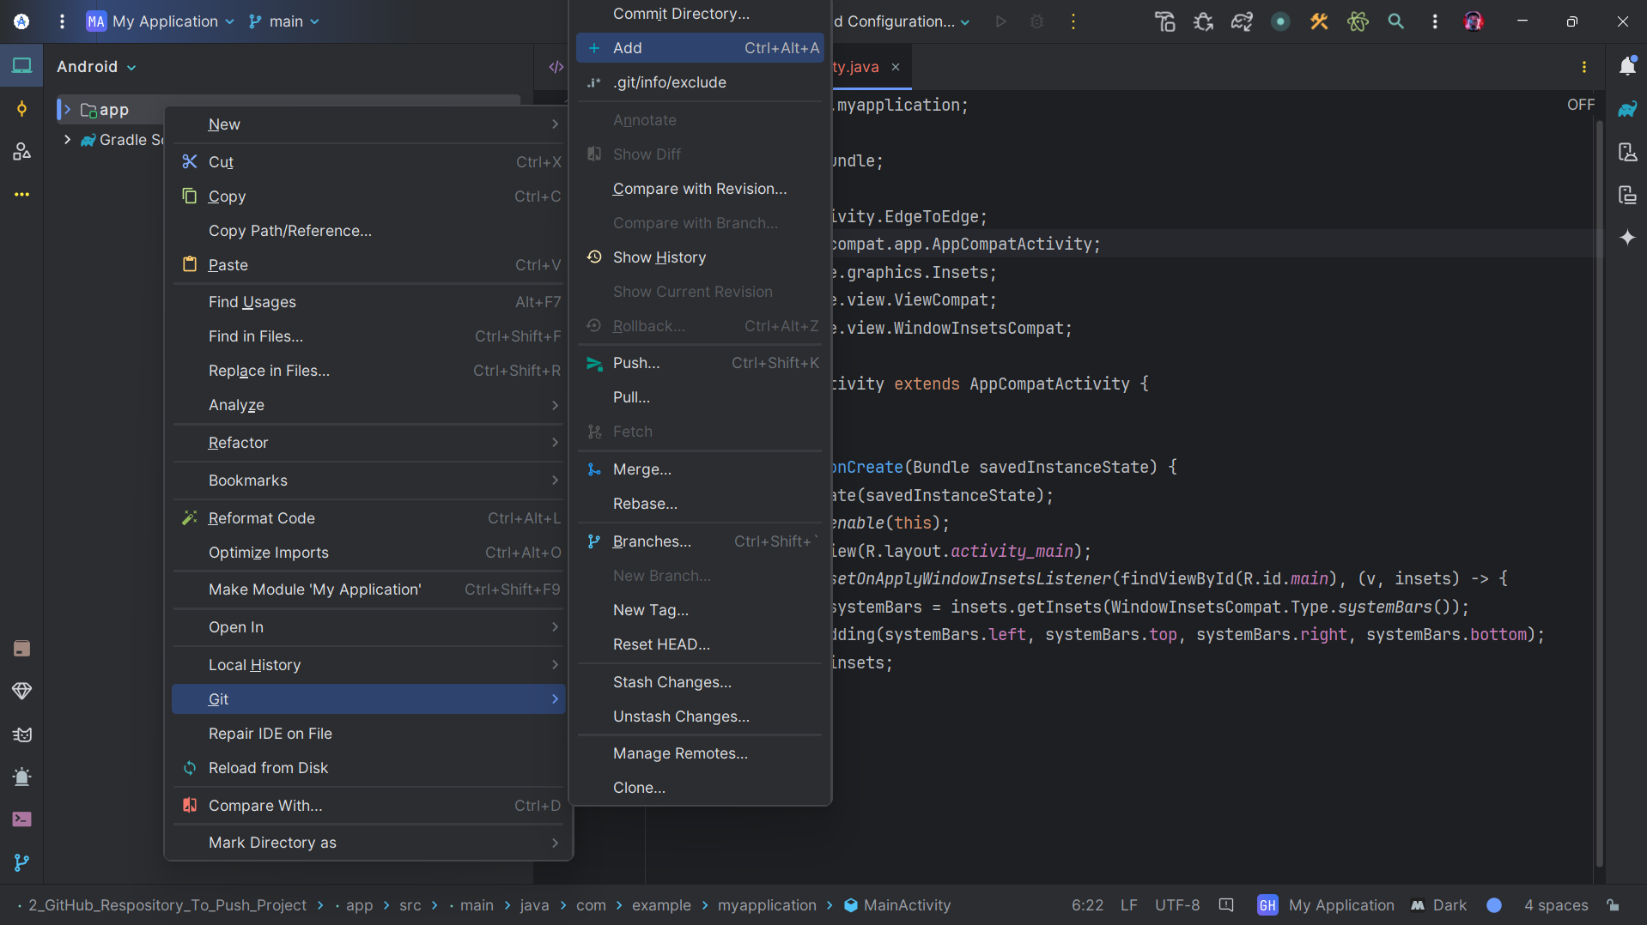

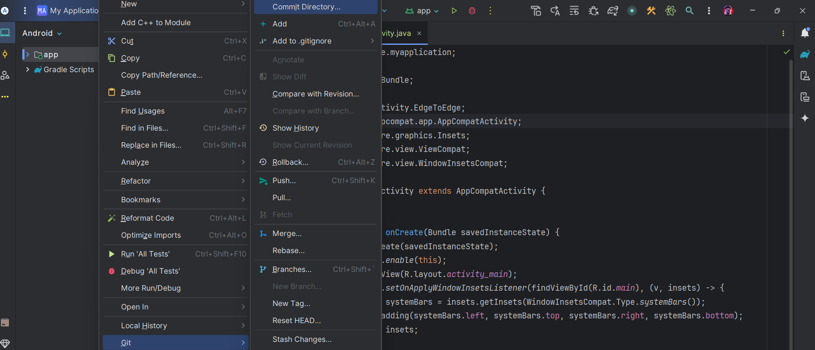

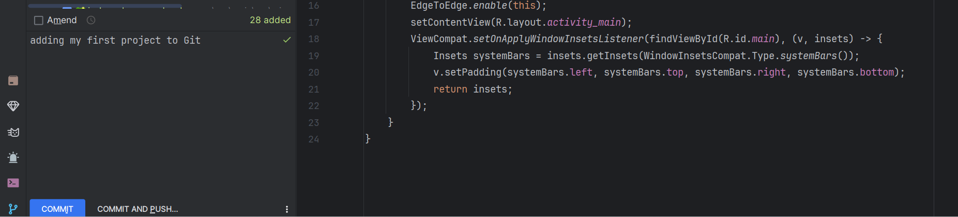

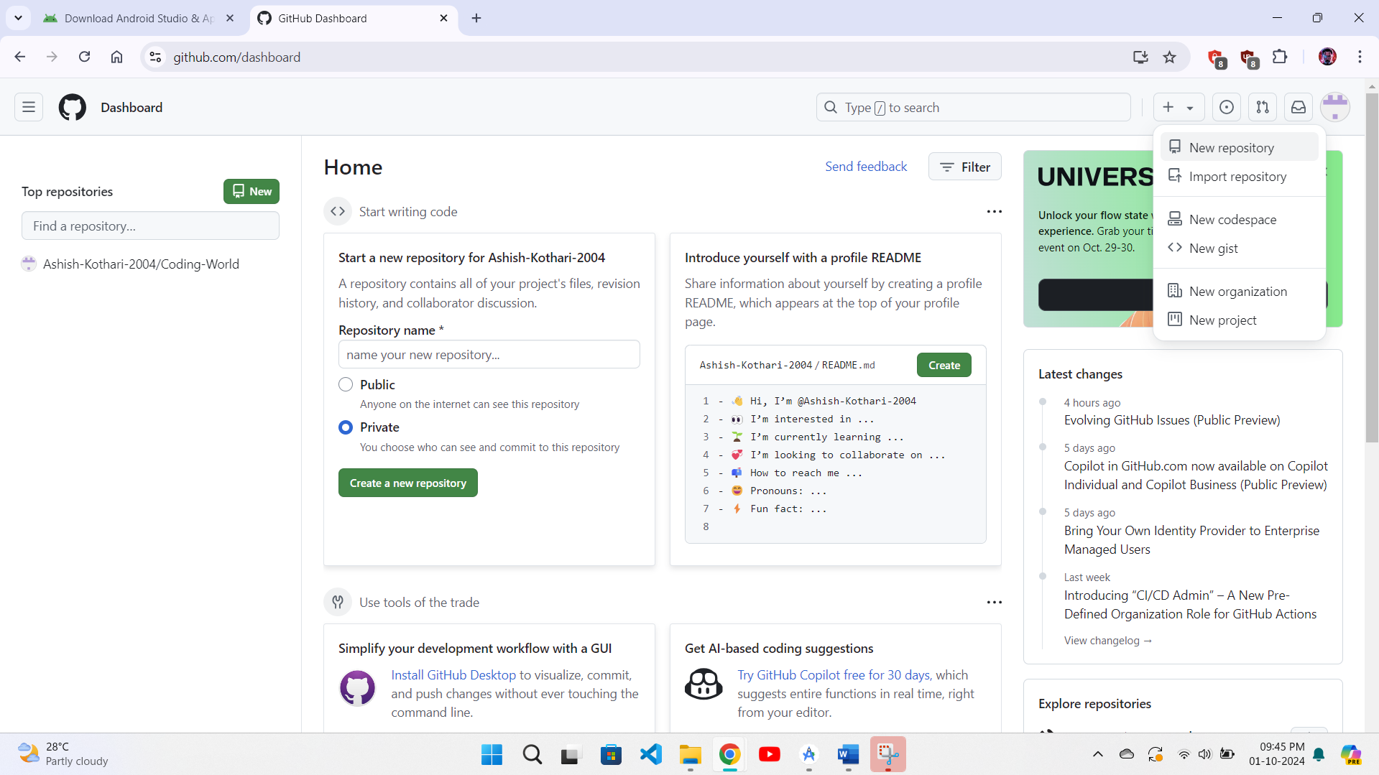

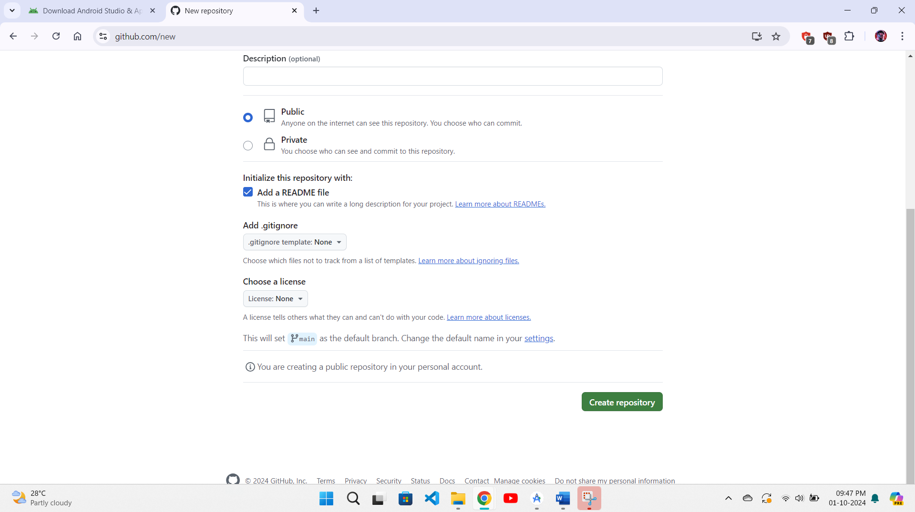

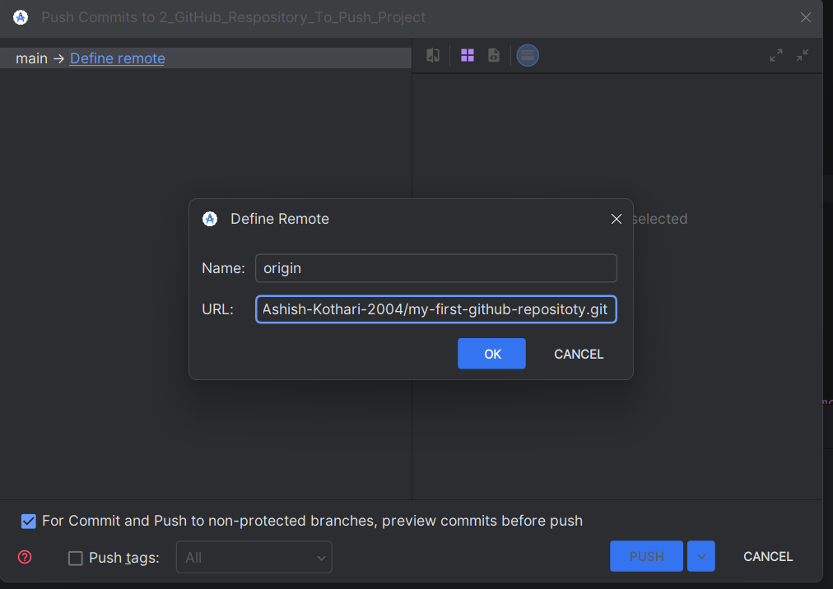

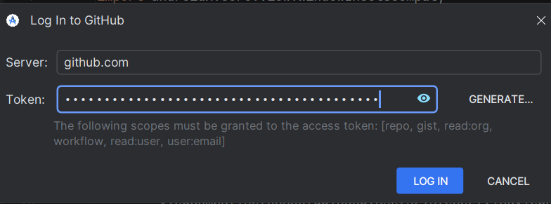

**Problem Statement 3:** Develop an android application to display a message “welcome to graphic era” on button click.

**Code:**

**activity_main.xml**

<?xml version="1.0" encoding="utf-8"?>

<LinearLayout xmlns:android="http://schemas.android.com/apk/res/android"

xmlns:app="http://schemas.android.com/apk/res-auto"

xmlns:tools="http://schemas.android.com/tools"

android:id="@+id/main"

android:layout_width="match_parent"

android:layout_height="match_parent"

tools:context=".MainActivity"

android:orientation="vertical"

android:gravity="center">

<Button

android:id="@+id/btn1"

android:layout_width="wrap_content"

android:layout_height="wrap_content"

android:text="@string/click"/>

</LinearLayout>

**MainActivity.java**

package com.example.toastmessage;  
import android.os.Bundle;  
import android.view.View;  
import android.widget.Button;  
import android.widget.Toast;  
import androidx.appcompat.app.AppCompatActivity;  
public class MainActivity extends AppCompatActivity {  
 @Override  
 protected void onCreate(Bundle savedInstanceState) {  
 super.onCreate(savedInstanceState);;  
 setContentView(R.layout.*activity_main*);  
 Button btn1 = findViewById(R.id.*btn1*);  
 btn1.setOnClickListener(new View.OnClickListener() {  
 @Override  
 public void onClick(View view) {  
 Toast.*makeText*(MainActivity.this, "Welcome To Graphic Era", Toast.*LENGTH_SHORT*).show();  
 }  
 });  
 }  
}

**Output:**

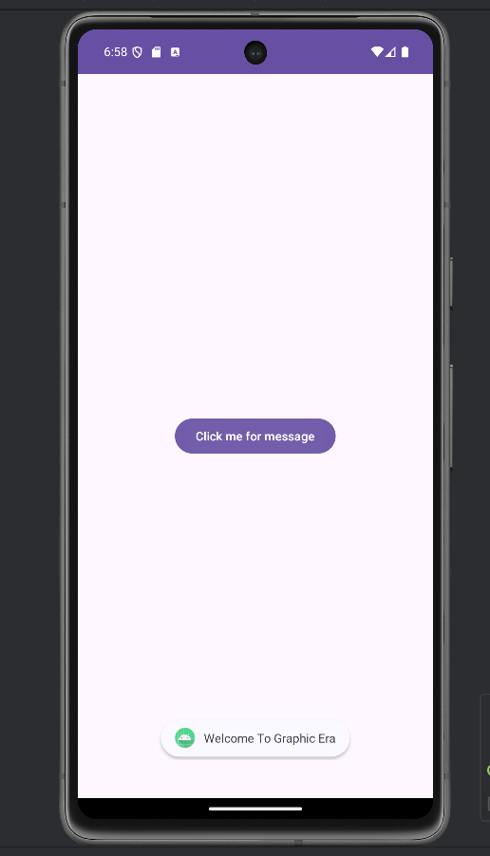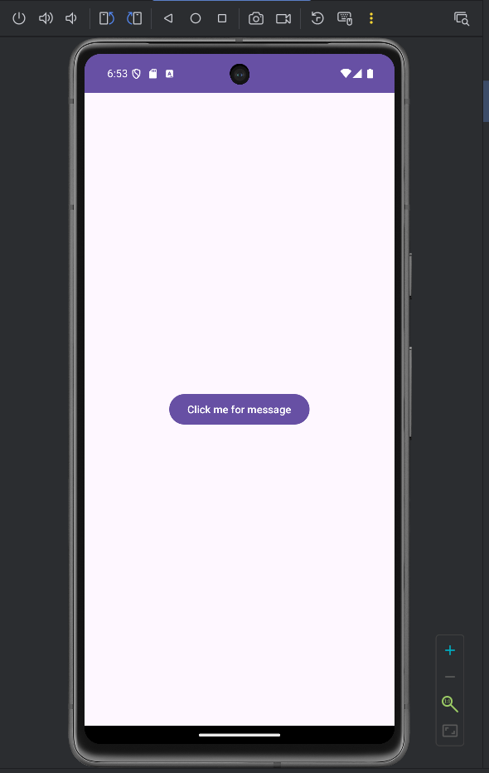

**Problem Statement 4:** Create an android application to change background color on button click.

**Code:**

**activity_main.xml**

<?xml version="1.0" encoding="utf-8"?>  
<LinearLayout xmlns:android="http://schemas.android.com/apk/res/android"  
 xmlns:app="http://schemas.android.com/apk/res-auto"  
 xmlns:tools="http://schemas.android.com/tools"  
 android:id="@+id/main"  
 android:layout_width="match_parent"  
 android:layout_height="match_parent"  
 tools:context=".MainActivity"  
 android:gravity="center">  
 <Button  
 android:id="@+id/btn1"  
 android:layout_width="wrap_content"  
 android:layout_height="wrap_content"  
 android:text="@string/click_background_color"  
 />  
</LinearLayout>

**MainActivity.java**

package com.example.changebackgroundcolor;  
import android.os.Bundle;  
import android.view.View;  
import android.widget.Button;  
import android.widget.LinearLayout;  
import androidx.activity.EdgeToEdge;  
import androidx.appcompat.app.AppCompatActivity;  
import androidx.core.graphics.Insets;  
import androidx.core.view.ViewCompat;  
import androidx.core.view.WindowInsetsCompat;  
public class MainActivity extends AppCompatActivity {  
 @Override  
 protected void onCreate(Bundle savedInstanceState) {  
 super.onCreate(savedInstanceState);  
 setContentView(R.layout.*activity_main*);  
 Button btn1 = findViewById(R.id.*btn1*);  
 LinearLayout background = findViewById(R.id.*main*);  
 btn1.setOnClickListener(new View.OnClickListener() {  
 @Override  
 public void onClick(View view) {  
 background.setBackgroundResource(R.color.*green*);  
 }  
 });  
 }  
}

**Output:**

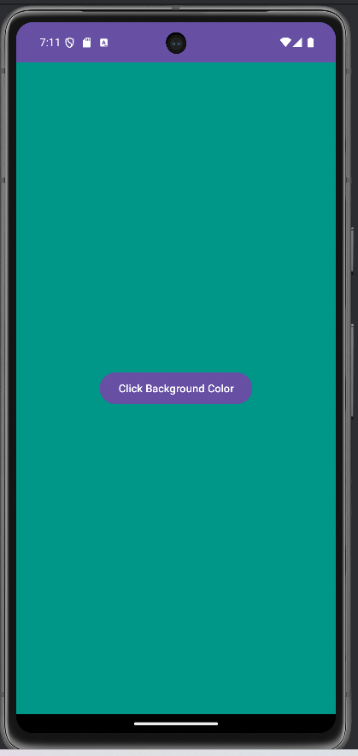 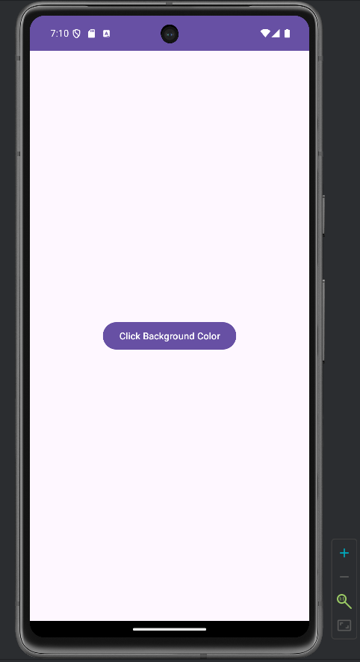

**Problem Statement 5:** Create an android application to add two numbers.

**Code:**

**activity_main.xml**

<?xml version="1.0" encoding="utf-8"?>  
<LinearLayout xmlns:android="http://schemas.android.com/apk/res/android"  
 xmlns:tools="http://schemas.android.com/tools"  
 android:id="@+id/main"  
 android:layout_width="match_parent"  
 android:layout_height="match_parent"  
 tools:context=".MainActivity"  
 android:orientation="vertical">  
 <EditText  
 android:id="@+id/num1"  
 android:layout_width="wrap_content"  
 android:layout_height="wrap_content"  
 android:autofillHints=""  
 android:hint="@string/enter_first_number"  
 android:layout_gravity="center_horizontal"  
 android:layout_margin="50dp"  
 android:inputType="numberDecimal"/>  
 <EditText  
 android:id="@+id/num2"  
 android:layout_width="wrap_content"  
 android:layout_height="wrap_content"  
 android:autofillHints=""  
 android:hint="@string/enter_second_number"  
 android:layout_gravity="center"  
 android:inputType="numberDecimal"/>  
 <TextView  
 android:id="@+id/result"  
 android:layout_width="wrap_content"  
 android:layout_height="wrap_content"  
 android:layout_gravity="center_horizontal"  
 android:layout_margin="80dp"  
 android:textSize="20sp"  
 android:textStyle="bold"/>  
 <Button  
 android:id="@+id/btn1"  
 android:layout_width="wrap_content"  
 android:layout_height="wrap_content"  
 android:text="@string/add"  
 android:layout_gravity="center_horizontal"  
 android:layout_margin="50dp"/>  
</LinearLayout>

**MainActivity.java**

package com.example.additionotwonumbers;  
import android.os.Bundle;  
import android.view.View;  
import android.widget.Button;  
import android.widget.EditText;  
import android.widget.TextView;  
import androidx.appcompat.app.AppCompatActivity;  
public class MainActivity extends AppCompatActivity {  
 @Override  
 protected void onCreate(Bundle savedInstanceState) {  
 super.onCreate(savedInstanceState);  
 setContentView(R.layout.*activity_main*);  
 EditText num1 = findViewById(R.id.*num1*);  
 EditText num2 = findViewById(R.id.*num2*);  
 TextView result = findViewById(R.id.*result*);  
 Button btn = findViewById(R.id.*btn1*);  
 btn.setOnClickListener(new View.OnClickListener() {  
 @Override  
 public void onClick(View view) {  
 double n1 = Double.*parseDouble*(num1.getText().toString());  
 double n2 = Double.*parseDouble*(num2.getText().toString());  
 double add = n1 + n2;  
 result.setText(String.*valueOf*(add));  
 }  
 });  
 }  
}

**Output:**

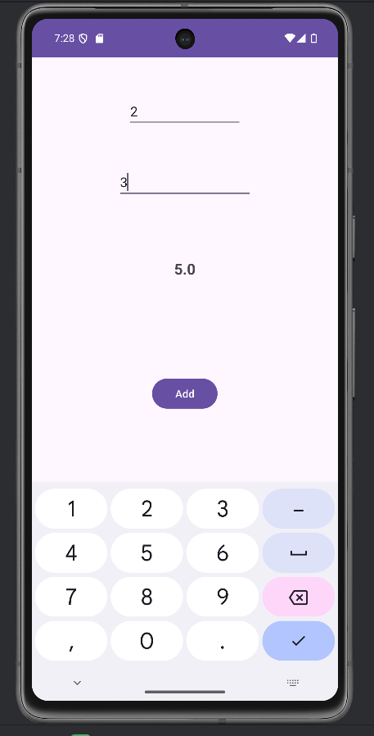

**Problem Statement 6:** Create an android application of calculator.

**Code:**

**activity_main.xml**

<?xml version="1.0" encoding="utf-8"?>  
<LinearLayout xmlns:android="http://schemas.android.com/apk/res/android"  
 android:layout_width="match_parent"  
 android:layout_height="match_parent"  
 android:orientation="vertical"  
 android:padding="16dp"  
 android:background="@color/background"  
 android:gravity="center_horizontal">  
 <!-- Display for the result -->  
 <TextView  
 android:id="@+id/resultText"  
 android:layout_width="match_parent"  
 android:layout_height="wrap_content"  
 android:gravity="end"  
 android:padding="16dp"  
 android:text="@string/_0"  
 android:textSize="32sp"  
 android:textColor="@color/black"  
 android:backgroundTint="@color/text_background"  
 android:background="@drawable/text_view_corner" />  
 <!-- Row 1: Numbers and basic operations -->  
 <GridLayout  
 android:layout_width="wrap_content"  
 android:layout_height="wrap_content"  
 android:columnCount="4"  
 android:rowCount="5"  
 android:layout_marginTop="480dp">  
 <!-- Buttons 1 to 9 -->  
 <Button  
 android:id="@+id/btn1"  
 android:layout_width="wrap_content"  
 android:layout_height="wrap_content"  
 android:text="@string/_1" />  
 <Button  
 android:id="@+id/btn2"  
 android:layout_width="wrap_content"  
 android:layout_height="wrap_content"  
 android:text="@string/_2"/>  
 <Button  
 android:id="@+id/btn3"  
 android:layout_width="wrap_content"  
 android:layout_height="wrap_content"  
 android:text="@string/_3" />  
 <Button  
 android:id="@+id/btnAdd"  
 android:layout_width="wrap_content"  
 android:layout_height="wrap_content"  
 android:text="@string/plus" />  
 <!-- Buttons 4 to 6 -->  
 <Button  
 android:id="@+id/btn4"  
 android:layout_width="wrap_content"  
 android:layout_height="wrap_content"  
 android:text="@string/_4" />  
 <Button  
 android:id="@+id/btn5"  
 android:layout_width="wrap_content"  
 android:layout_height="wrap_content"  
 android:text="@string/_5" />  
 <Button  
 android:id="@+id/btn6"  
 android:layout_width="wrap_content"  
 android:layout_height="wrap_content"  
 android:text="@string/_6" />  
 <Button  
 android:id="@+id/btnSubtract"  
 android:layout_width="wrap_content"  
 android:layout_height="wrap_content"  
 android:text="@string/minus" />  
 <!-- Buttons 7 to 9 -->  
 <Button  
 android:id="@+id/btn7"  
 android:layout_width="wrap_content"  
 android:layout_height="wrap_content"  
 android:text="@string/_7" />  
 <Button  
 android:id="@+id/btn8"  
 android:layout_width="wrap_content"  
 android:layout_height="wrap_content"  
 android:text="@string/_8" />  
 <Button  
 android:id="@+id/btn9"  
 android:layout_width="wrap_content"  
 android:layout_height="wrap_content"  
 android:text="@string/_9" />  
 <Button  
 android:id="@+id/btnMultiply"  
 android:layout_width="wrap_content"  
 android:layout_height="wrap_content"  
 android:text="@string/multiplication" />  
 <!-- Button 0, Clear, Equal, and Divide -->  
 <Button  
 android:id="@+id/btnClear"  
 android:layout_width="wrap_content"  
 android:layout_height="wrap_content"  
 android:text="@string/c" />  
 <Button  
 android:id="@+id/btn0"  
 android:layout_width="wrap_content"  
 android:layout_height="wrap_content"  
 android:text="@string/_0" />  
 <Button  
 android:id="@+id/btnEqual"  
 android:layout_width="wrap_content"  
 android:layout_height="wrap_content"  
 android:text="@string/equal" />  
 <Button  
 android:id="@+id/btnDivide"  
 android:layout_width="wrap_content"  
 android:layout_height="wrap_content"  
 android:text="@string/divide" />  
 </GridLayout>  
</LinearLayout>

**MainActivity.java**

package com.example.calculator;  
import android.os.Bundle;  
import android.view.View;  
import android.widget.Button;  
import android.widget.TextView;  
import androidx.appcompat.app.AppCompatActivity;  
public class MainActivity extends AppCompatActivity {  
 TextView resultText;  
 String currentOperator = "";  
 String currentNumber = "";  
 double operand1 = 0, operand2 = 0;  
 @Override  
 protected void onCreate(Bundle savedInstanceState) {  
 super.onCreate(savedInstanceState);  
 setContentView(R.layout.*activity_main*);  
 resultText = findViewById(R.id.*resultText*);  
 int[] numberButtons = {R.id.*btn0*, R.id.*btn1*, R.id.*btn2*, R.id.*btn3*, R.id.*btn4*, R.id.*btn5*, R.id.*btn6*, R.id.*btn7*, R.id.*btn8*, R.id.*btn9*};  
 for (int id : numberButtons) {  
 findViewById(id).setOnClickListener(new View.OnClickListener() {  
 @Override  
 public void onClick(View view) {  
 Button button = (Button) view;  
 currentNumber += button.getText().toString();  
 resultText.setText(currentNumber);  
 }  
 });  
 }  
 findViewById(R.id.*btnAdd*).setOnClickListener(new OperatorClickListener("+"));  
 findViewById(R.id.*btnSubtract*).setOnClickListener(new OperatorClickListener("-"));  
 findViewById(R.id.*btnMultiply*).setOnClickListener(new OperatorClickListener("*"));  
 findViewById(R.id.*btnDivide*).setOnClickListener(new OperatorClickListener("/"));  
 // Clear button  
 findViewById(R.id.*btnClear*).setOnClickListener(new View.OnClickListener() {  
 @Override  
 public void onClick(View view) {  
 currentNumber = "";  
 currentOperator = "";  
 operand1 = 0;  
 operand2 = 0;  
 resultText.setText("0");  
 }  
 });  
 findViewById(R.id.*btnEqual*).setOnClickListener(new View.OnClickListener() {  
 @Override  
 public void onClick(View view) {  
 if (!currentNumber.equals("") && !currentOperator.equals("")) {  
 operand2 = Double.*parseDouble*(currentNumber);  
 double result = 0;  
 switch (currentOperator) {  
 case "+":  
 result = operand1 + operand2;  
 break;  
 case "-":  
 result = operand1 - operand2;  
 break;  
 case "*":  
 result = operand1 * operand2;  
 break;  
 case "/":  
 if (operand2 != 0) {  
 result = operand1 / operand2;  
 } else {  
 resultText.setText("Error");  
 return;  
 }  
 break;  
 }  
 resultText.setText(String.*valueOf*(result));  
 currentNumber = "";  
 currentOperator = "";  
 operand1 = result;  
 }  
 }  
 });  
 }  
 private class OperatorClickListener implements View.OnClickListener {  
 private final String operator;  
 OperatorClickListener(String operator) {  
 this.operator = operator;  
 }  
 @Override  
 public void onClick(View view) {  
 if (!currentNumber.equals("")) {  
 operand1 = Double.*parseDouble*(currentNumber);  
 currentOperator = operator;  
 currentNumber = "";  
 }  
 }  
 }  
}

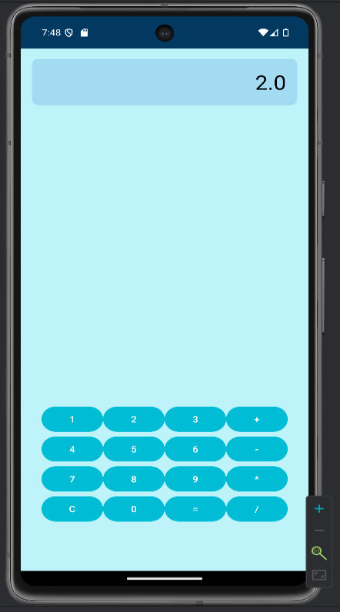**Output:**

**Problem Statement 7:** Create an application to set image on image view.

**Code:**

**activity_main.xml**

<?xml version="1.0" encoding="utf-8"?>  
<LinearLayout xmlns:android="http://schemas.android.com/apk/res/android"  
 xmlns:app="http://schemas.android.com/apk/res-auto"  
 xmlns:tools="http://schemas.android.com/tools"  
 android:id="@+id/main"  
 android:layout_width="match_parent"  
 android:layout_height="match_parent"  
 tools:context=".MainActivity">  
 <ImageView  
 android:layout_width="wrap_content"  
 android:layout_height="match_parent"  
 android:contentDescription="set_images"  
 android:src="@drawable/avatar"/>  
</LinearLayout>

**MainActivity.java**

package com.example.setimageview;  
import android.os.Bundle;  
import androidx.appcompat.app.AppCompatActivity;  
public class MainActivity extends AppCompatActivity {  
 @Override  
 protected void onCreate(Bundle savedInstanceState) {  
 super.onCreate(savedInstanceState);  
 setContentView(R.layout.*activity_main*);  
 }  
}

**Output:**

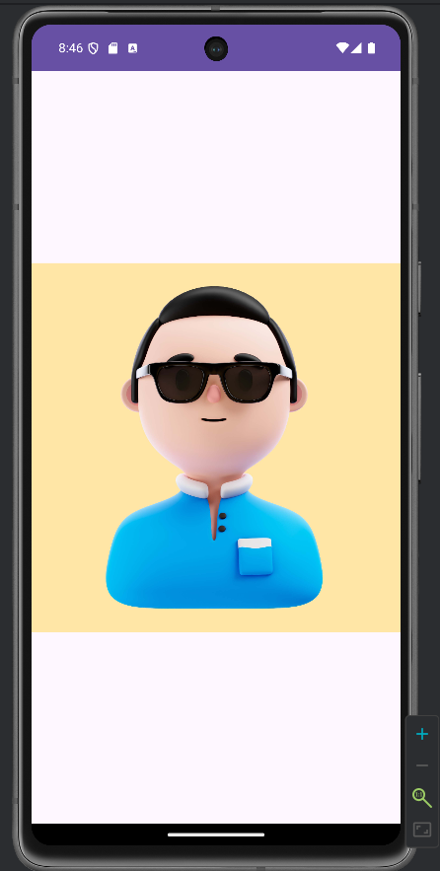

**Problem Statement 8:** Create a program to depict android activity life cycle

**Code:**

**activity_main.xml**

<?xml version="1.0" encoding="utf-8"?>  
<LinearLayout xmlns:android="http://schemas.android.com/apk/res/android"  
 xmlns:app="http://schemas.android.com/apk/res-auto"  
 xmlns:tools="http://schemas.android.com/tools"  
 android:id="@+id/main"  
 android:layout_width="match_parent"  
 android:layout_height="match_parent"  
 tools:context=".MainActivity">  
 <TextView  
 android:layout_width="wrap_content"  
 android:layout_height="wrap_content"  
 android:text="Hello World!"/>  
</LinearLayout>

**MainActivity.java**

package com.example.activitylifecycleusinglogcat;  
import android.os.Bundle;  
import android.util.Log;  
import androidx.appcompat.app.AppCompatActivity;  
public class MainActivity extends AppCompatActivity {  
 public static final String *status* = MainActivity.class.getSimpleName();  
 @Override  
 protected void onCreate(Bundle savedInstanceState) {  
 super.onCreate(savedInstanceState);  
 setContentView(R.layout.*activity_main*);  
 Log.*e*(*status*, "onCreate: Inside onCreate method");  
 }  
 @Override  
 protected void onStart() {  
 super.onStart();  
 Log.*e*(*status*, "onStart: Inside onStart method");  
 }  
 @Override  
 protected void onRestart() {  
 super.onRestart();  
 Log.*e*(*status*, "onRestart: Inside onRestart method");  
 }  
 protected void onResume() {  
 super.onResume();  
 Log.*e*(*status*, "onResume: Inside onResume method");  
 }  
 protected void onPause(){  
 super.onPause();  
 Log.*e*(*status*, "onResume: Inside onPause method");  
 }  
 @Override  
 protected void onStop() {  
 super.onStop();  
 Log.*e*(*status*, "onStop: Inside onStop method");  
 }  
 @Override  
 protected void onDestroy() {  
 super.onDestroy();  
 Log.*e*(*status*, "onDestroy: Inside onDestroy method");  
 }  
}

**Output:**

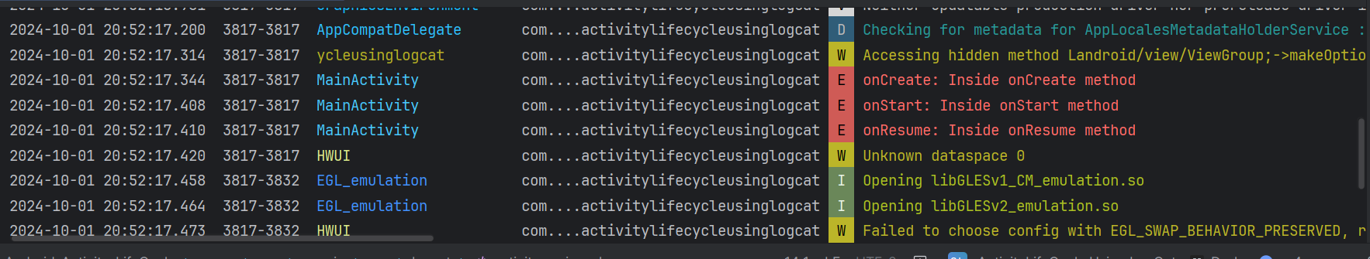

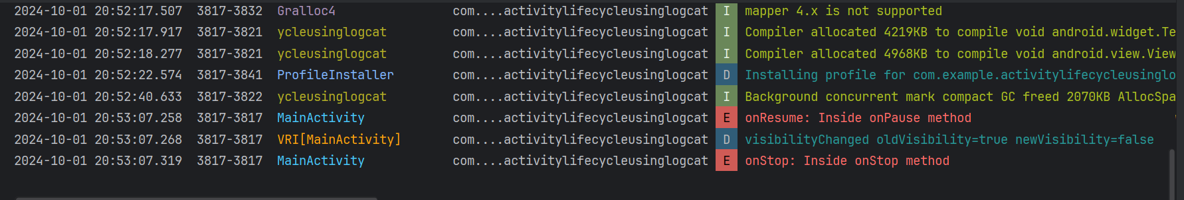

**Problem Statement 9:** Create a program to show implicit intent

**Code:**

**activity_main.xml**

<?xml version="1.0" encoding="utf-8"?>  
<RelativeLayout xmlns:android="http://schemas.android.com/apk/res/android"  
 xmlns:app="http://schemas.android.com/apk/res-auto"  
 xmlns:tools="http://schemas.android.com/tools"  
 android:id="@+id/main"  
 android:layout_width="match_parent"  
 android:layout_height="match_parent"  
 tools:context=".MainActivity"  
 android:gravity="center">  
 <Button  
 android:id="@+id/btn"  
 android:layout_width="171dp"  
 android:layout_height="43dp"  
 android:text="@string/click_here" />  
</RelativeLayout>

**MainActivity.java**

package com.example.implicitintent;  
import android.content.Intent;  
import android.net.Uri;  
import android.os.Bundle;  
import android.view.View;  
import android.widget.Button;  
import androidx.appcompat.app.AppCompatActivity;  
public class MainActivity extends AppCompatActivity {  
 @Override  
 protected void onCreate(Bundle savedInstanceState) {  
 super.onCreate(savedInstanceState);  
 setContentView(R.layout.*activity_main*);  
 Button btn1 = findViewById(R.id.*btn*);  
 btn1.setOnClickListener(new View.OnClickListener() {  
 @Override  
 public void onClick(View view) {  
 String url = "https://www.youtube.com/";  
 Intent implicitIntent = new Intent(Intent.*ACTION_VIEW*, Uri.*parse*(url));  
 startActivity(implicitIntent);  
 }  
 });  
 }  
}

**Output:**

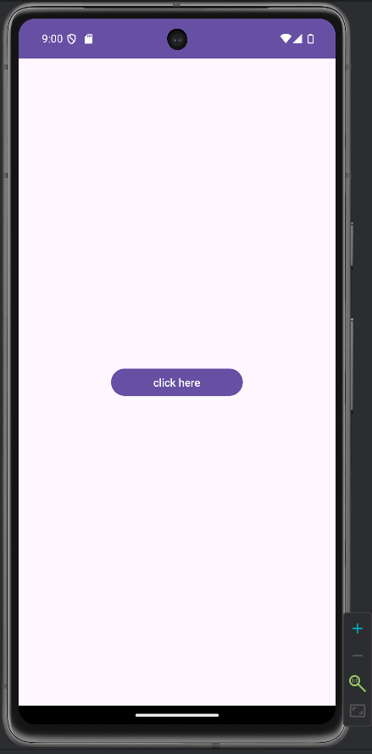

**Problem Statement 10:** Create a program to show explicit intent.

**Code:**

**activity_main.xml**

<?xml version="1.0" encoding="utf-8"?>  
<RelativeLayout xmlns:android="http://schemas.android.com/apk/res/android"  
 xmlns:tools="http://schemas.android.com/tools"  
 android:id="@+id/main"  
 android:layout_width="match_parent"  
 android:layout_height="match_parent"  
 tools:context=".MainActivity">  
 <Button  
 android:id="@+id/btn"  
 android:layout_width="wrap_content"  
 android:layout_height="wrap_content"  
 android:text="@string/next"  
 android:layout_alignParentStart="true"  
 android:layout_alignParentTop="true"  
 android:layout_alignParentEnd="true"  
 android:layout_alignParentBottom="true"  
 android:layout_marginStart="300dp"  
 android:layout_marginTop="700dp"  
 android:layout_marginEnd="20dp"  
 android:layout_marginBottom="50dp" />  
</RelativeLayout>

**MainActivity.java**

package com.example.explicitintent;  
import android.content.Intent;  
import android.os.Bundle;  
import android.view.View;  
import android.widget.Button;  
import androidx.appcompat.app.AppCompatActivity;  
public class MainActivity extends AppCompatActivity {  
 @Override  
 protected void onCreate(Bundle savedInstanceState) {  
 super.onCreate(savedInstanceState);  
 setContentView(R.layout.*activity_main*);  
 Button btn = findViewById(R.id.*btn*);  
 btn.setOnClickListener(new View.OnClickListener() {  
 @Override  
 public void onClick(View view) {  
 Intent explicitIntent = new Intent(MainActivity.this, SecondActivity.class);  
 startActivity(explicitIntent);  
 }  
 });  
 }  
}

**activity_second.xml**

<?xml version="1.0" encoding="utf-8"?>  
<RelativeLayout xmlns:android="http://schemas.android.com/apk/res/android"  
 android:layout_width="match_parent"  
 android:layout_height="match_parent"  
 android:gravity="center">  
 <TextView  
 android:layout_width="wrap_content"  
 android:layout_height="wrap_content"  
 android:text="@string/hello_world"  
 android:textSize="22sp"  
 android:textStyle="bold"/>  
</RelativeLayout>

**SecondActivity.java**

package com.example.explicitintent;  
import android.os.Bundle;  
import androidx.annotation.Nullable;  
import androidx.appcompat.app.AppCompatActivity;  
public class SecondActivity extends AppCompatActivity {  
 @Override  
 protected void onCreate(@Nullable Bundle savedInstanceState) {  
 super.onCreate(savedInstanceState);  
 setContentView(R.layout.*activity_second*);  
 }  
}

**Output:**

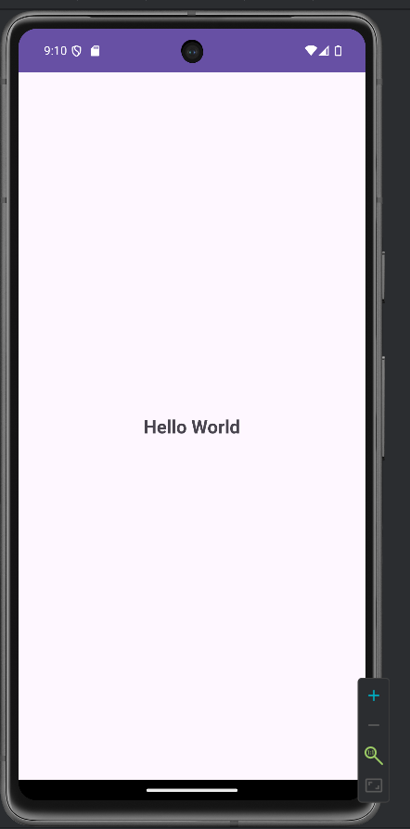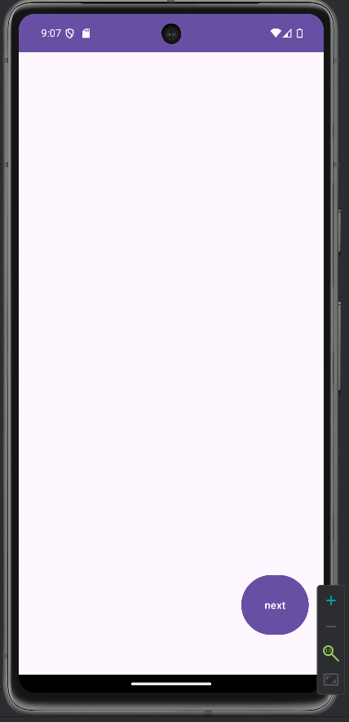

**Problem Statement 11:** Develop an android application to demonstrate Event Listener and Event Handlers.

**Code:**

**activity_main.xml**

<?xml version="1.0" encoding="utf-8"?>  
<LinearLayout xmlns:android="http://schemas.android.com/apk/res/android"  
 android:layout_width="match_parent"  
 android:layout_height="match_parent"  
 android:orientation="vertical"  
 android:gravity="center"  
 android:padding="16dp">  
 <TextView  
 android:id="@+id/textView"  
 android:layout_width="wrap_content"  
 android:layout_height="wrap_content"  
 android:text="@string/hello_click_the_button"  
 android:textSize="20sp"  
 android:layout_marginBottom="20dp"/>  
 <Button  
 android:id="@+id/button"  
 android:layout_width="wrap_content"  
 android:layout_height="wrap_content"  
 android:text="@string/click_me" />  
</LinearLayout>

**MainActivity.java**

package com.example.eventlistenersandhandlers;  
import android.os.Bundle;  
import android.view.View;  
import android.widget.Button;  
import android.widget.TextView;  
import androidx.appcompat.app.AppCompatActivity;  
public class MainActivity extends AppCompatActivity {  
 private TextView textView;  
 private Button button;  
 @Override  
 protected void onCreate(Bundle savedInstanceState) {  
 super.onCreate(savedInstanceState);  
 setContentView(R.layout.*activity_main*);  
 // Reference the UI elements  
 textView = findViewById(R.id.*textView*);  
 button = findViewById(R.id.*button*);  
 // Set the event listener for the button  
 button.setOnClickListener(new View.OnClickListener() {  
 @Override  
 public void onClick(View v) {  
 // Handle the button click event  
 textView.setText("Button clicked!");  
 }  
 });  
 }  
}

**Output:**

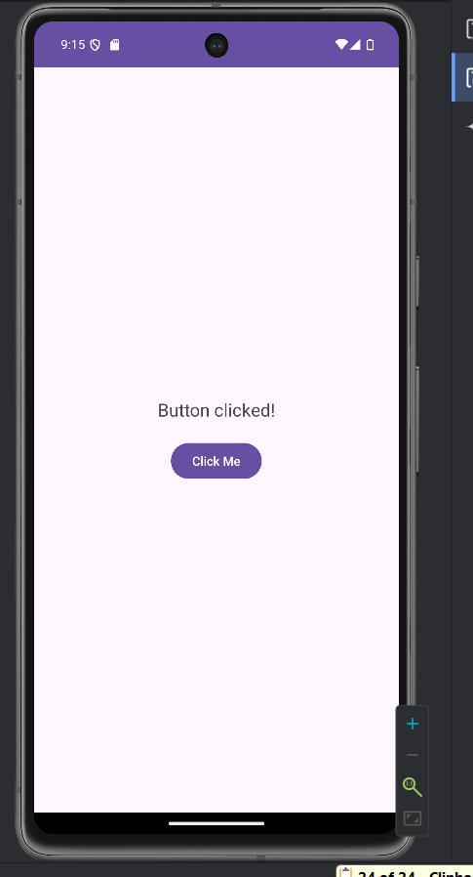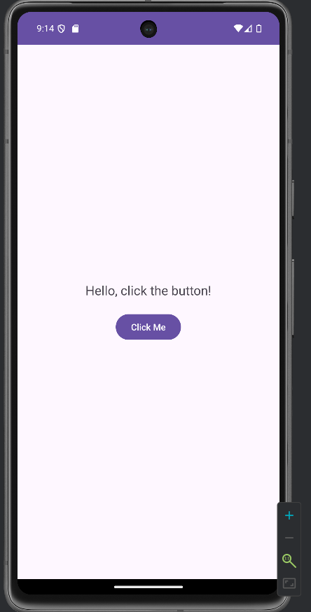

**Problem Statement 12:** Develop an android application to create two buttons and switch between images on button click.

**Code:**

**activity_main.xml**

<?xml version="1.0" encoding="utf-8"?>  
<LinearLayout xmlns:android="http://schemas.android.com/apk/res/android"  
 android:layout_width="match_parent"  
 android:layout_height="match_parent"  
 android:orientation="vertical"  
 android:gravity="center"  
 android:padding="16dp">  
 <ImageView  
 android:id="@+id/imageView"  
 android:layout_width="250dp"  
 android:layout_height="250dp"  
 android:src="@drawable/avatar1"  
 android:contentDescription="@string/image_placeholder"  
 android:layout_marginBottom="20dp" />  
 <Button  
 android:id="@+id/buttonImage1"  
 android:layout_width="wrap_content"  
 android:layout_height="wrap_content"  
 android:text="@string/show_image_1" />  
 <Button  
 android:id="@+id/buttonImage2"  
 android:layout_width="wrap_content"  
 android:layout_height="wrap_content"  
 android:text="@string/show_image_2"  
 android:layout_marginTop="10dp" />  
</LinearLayout>

**MainActivity.java**

package com.example.switchbetweenimages;  
import android.os.Bundle;  
import android.view.View;  
import android.widget.Button;  
import android.widget.ImageView;  
import androidx.appcompat.app.AppCompatActivity;  
public class MainActivity extends AppCompatActivity {  
 @Override  
 protected void onCreate(Bundle savedInstanceState) {  
 super.onCreate(savedInstanceState);  
 setContentView(R.layout.*activity_main*);  
 ImageView imageView = findViewById(R.id.*imageView*);  
 Button buttonImage1 = findViewById(R.id.*buttonImage1*);  
 Button buttonImage2 = findViewById(R.id.*buttonImage2*);  
 buttonImage1.setOnClickListener(new View.OnClickListener() {  
 @Override  
 public void onClick(View v) {  
 imageView.setImageResource(R.drawable.*avatar1*);  
 }  
 });  
 buttonImage2.setOnClickListener(new View.OnClickListener() {  
 @Override  
 public void onClick(View v) {  
 imageView.setImageResource(R.drawable.*avatar2*);  
 }  
 });  
 }  
}

**Output:**

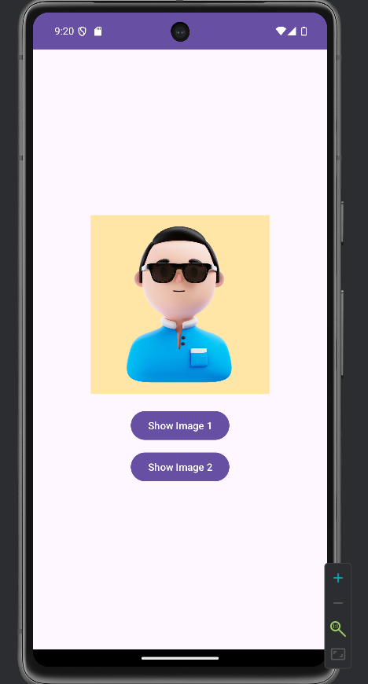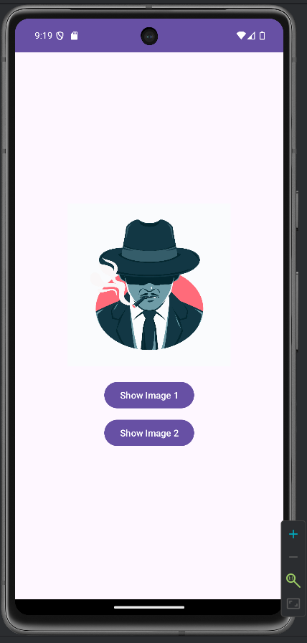

**Problem Statement 13:** Develop an android application to display toast message on button click.

**Code:**

**activity_main.xml**

<?xml version="1.0" encoding="utf-8"?>  
<LinearLayout xmlns:android="http://schemas.android.com/apk/res/android"  
 xmlns:tools="http://schemas.android.com/tools"  
 android:id="@+id/main"  
 android:layout_width="match_parent"  
 android:layout_height="match_parent"  
 tools:context=".MainActivity"  
 android:orientation="vertical"  
 android:gravity="center">  
 <Button  
 android:id="@+id/btn1"  
 android:layout_width="wrap_content"  
 android:layout_height="wrap_content"  
 android:text="@string/click" />  
</LinearLayout>

**MainActivtiy.java**

package com.example.toastmessage;  
import android.os.Bundle;  
import android.view.View;  
import android.widget.Button;  
import android.widget.Toast;  
import androidx.appcompat.app.AppCompatActivity;  
public class MainActivity extends AppCompatActivity {  
 @Override  
 protected void onCreate(Bundle savedInstanceState) {  
 super.onCreate(savedInstanceState);;  
 setContentView(R.layout.*activity_main*);  
 Button btn1 = findViewById(R.id.*btn1*);  
 btn1.setOnClickListener(new View.OnClickListener() {  
 @Override  
 public void onClick(View view) {  
 Toast.*makeText*(MainActivity.this, "Displaying toast message", Toast.*LENGTH_LONG*).show();  
 }  
 });  
 }  
}

**Output:**

